# Troubleshooting Cloud Challenges: Real-world Scenarios and Solutions- PART-01

Addressing common cloud issues and their solutions

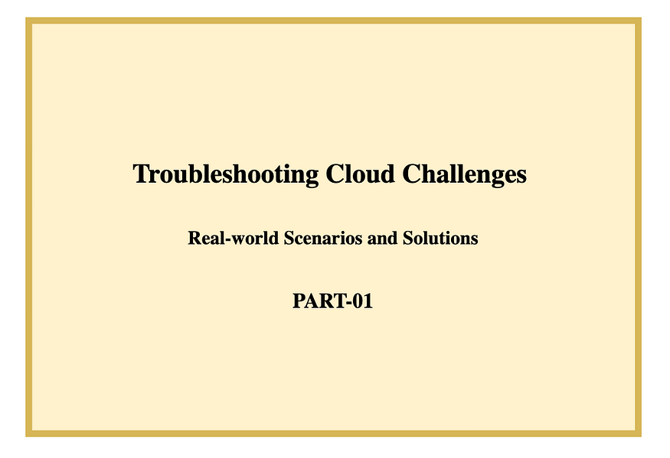

**Welcome to our blog series on “Troubleshooting Cloud Challenges: Real-world Scenarios and Solutions.”**

In this series, we address common cloud issues and provide practical solutions to empower you with the essential troubleshooting skills for a seamless cloud experience.

Let’s dive in and conquer cloud complexities together!

## **Scenario 1**: **“Website Unreachable”**

You have deployed a web application on Azure or AWS, and users are reporting that the website is not accessible. You need to troubleshoot and resolve the issue.

**Possible Solutions:**

1. Check the Network Security Group (NSG) or Security Group (SG) rules: Ensure that the appropriate inbound rules are configured to allow HTTP/HTTPS traffic to the web server.
2. Review Network Load Balancer (NLB) or Application Load Balancer (ALB) settings: Verify the health checks and target group settings if you are using load balancers to distribute traffic to multiple instances.
3. Examine the Virtual Machine (VM) or EC2 instance status: Ensure that the VM or EC2 instance hosting the web application is running and has no critical issues.
4. Review DNS settings: Check that the DNS records are correctly configured and pointing to the correct IP address or load balancer endpoint.
5. Inspect web server logs: Analyze the logs on the VM or EC2 instance to identify any errors or issues related to the web application.

## **Scenario 2: “High CPU Utilization”**

You notice that one of your virtual machines or EC2 instances is experiencing high CPU utilization, impacting application performance.

**Possible Solutions:**

1. Scale the instance: Consider upgrading the VM instance size to one with higher CPU resources to handle the increased load.
2. Optimize code and applications: Review the application code and optimize any inefficient processes or queries that might be causing high CPU usage.
3. Load balancing and Auto Scaling: Implement load balancing and auto-scaling groups to distribute the load across multiple instances and automatically adjust capacity based on demand.
4. Use monitoring and alerting: Set up monitoring and alerting for CPU utilization to proactively identify and address high usage issues.

## Scenario 3: “Data Backup Failure”

Your database backups are failing consistently, and you need to troubleshoot the backup process.

**Possible Solutions:**

1. Check permissions and IAM roles: Ensure that the backup process has appropriate permissions to access and write to the backup location (e.g., S3 bucket, Azure Storage).
2. Verify storage space: Ensure that there is enough space available in the backup destination to accommodate the backups.
3. Review backup configuration: Double-check the backup settings to ensure they are correctly configured, including backup frequency and retention policies.
4. Test backup and restore process: Perform a test backup and restore to confirm that the backup process is functioning correctly.

## Scenario 4: “Application Deployment Error”

You are trying to deploy a new version of your application, but the deployment is failing with an error message.

**Possible Solutions:**

1. Review deployment logs: Examine the deployment logs to identify the specific error message and pinpoint the root cause.
2. Check dependencies: Ensure that all required dependencies and resources (e.g., database, storage accounts) are available and accessible.
3. Rollback changes: If possible, revert to the previous version of the application to maintain service availability while troubleshooting the deployment issue.
4. Validate deployment scripts: Verify that any deployment scripts or automation processes are correctly configured and executing the deployment steps accurately.

## Scenario 5: “S3 Bucket Access Denied”

You are trying to access an S3 bucket, but you receive an “Access Denied” error.

**Possible Solutions:**

1. Check IAM permissions: Ensure that the IAM user or role you are using to access the bucket has the necessary permissions (e.g., s3:GetObject) attached to their policy.
2. Bucket Policy and ACLs: Review the bucket’s access control policies and Access Control Lists (ACLs) to confirm that they allow the desired access.
3. CORS Configuration: If you are accessing the bucket from a web application using JavaScript, verify that the Cross-Origin Resource Sharing (CORS) configuration allows the necessary origin.

## Scenario 6: “RDS Database Connection Failure”

Your application is unable to connect to the Amazon RDS database.

**Possible Solutions:**

1. Check security group rules: Ensure that the security group associated with the RDS instance allows inbound connections from the application’s server or security group.
2. Verify database endpoint: Confirm that the application is using the correct RDS instance endpoint (including the port number) in its connection string.
3. Database credentials: Double-check the username and password used in the application’s database configuration to ensure they are correct.

## Scenario 7: “Lambda Function Timeout”

Your AWS Lambda function is timing out before completing the task.

**Possible Solutions:**

1. Increase function timeout: Adjust the function’s timeout setting to provide it with more time to complete its execution.
2. Optimize code: Review the Lambda function’s code and look for opportunities to optimize and reduce execution time.
3. Check resources and concurrency: Ensure that the function has enough allocated resources (e.g., memory) and check if there are any issues related to Lambda concurrency limits.

## Scenario 8: “Auto Scaling Group Not Scaling”

Your Auto Scaling group is not scaling in or out as expected based on demand.

**Possible Solutions:**

1. Check scaling policies: Verify the scaling policies attached to the Auto Scaling group and ensure they are correctly configured to respond to the desired metrics (e.g., CPU utilization, request count).
2. Instance limits: Ensure that you have not reached any EC2 instance limits in your AWS account that could prevent scaling.
3. Health checks: Confirm that the health checks associated with the Auto Scaling group are passing correctly, as failing health checks can prevent scaling actions.

## Scenario 9: “DynamoDB Throughput Errors”

Your DynamoDB table is experiencing “ProvisionedThroughputExceededException” errors.

**Possible Solutions:**

1. Increase provisioned throughput: Scale up the provisioned read and write capacity of the DynamoDB table to handle the higher request rate.
2. Examine usage patterns: Analyze the application’s access patterns to identify if certain keys or partitions are hotspots and consider partitioning strategies.
3. Use on-demand capacity: Switch the table to on-demand capacity mode if the workload is highly variable and unpredictable.

## Scenario 10: “Elastic Beanstalk Deployment Failure”

Your Elastic Beanstalk application deployment is failing.

**Possible Solutions:**

1. Review application logs: Check Elastic Beanstalk logs for any error messages or exceptions that might indicate the cause of the deployment failure.
2. Check IAM permissions: Ensure the IAM roles associated with the Elastic Beanstalk environment have the necessary permissions to access other AWS services required for the deployment.
3. Validate deployment package: Verify that the application package being deployed is correct and includes all necessary files and dependencies.

## Scenario 11: “S3 Bucket Cross-Region Replication Issue”

Cross-Region replication for an S3 bucket is not working as expected.

**Possible Solutions:**

1. Confirm IAM roles: Ensure that the IAM roles used for cross-region replication have appropriate permissions on both source and destination buckets.
2. Verify bucket names: Check that the bucket names and configurations in the replication rules are accurate and match the intended setup.
3. Check AWS Region Support: Ensure that the source and destination AWS Regions support cross-region replication.

## Scenario 12: “CloudFront Distribution Misconfiguration”

Your CloudFront distribution is not serving content as expected.

**Possible Solutions:**

1. Check origin settings: Verify that the origin (e.g., S3 bucket, EC2 instance) associated with the CloudFront distribution is correctly configured.
2. Confirm Cache Behavior settings: Review the Cache Behavior settings to ensure proper cache control headers and caching behaviors.
3. Check distribution status: Ensure that the CloudFront distribution is in the “Deployed” state and has propagated changes globally.

## Scenario 13: “RDS Multi-AZ Failover”

Your RDS Multi-AZ deployment is experiencing a failover event.

**Possible Solutions:**

1. Check RDS instance health: Investigate the underlying cause of the primary instance’s failure, such as storage issues or instance health.
2. Monitor failover duration: Monitor the failover process and check if the secondary instance becomes the new primary.
3. Review RDS event logs: Examine RDS event logs to understand the details of the failover event.

## Scenario 14: “ECS Task Stuck in Pending State”

Your ECS task is stuck in the “PENDING” state and not launching.

**Possible Solutions:**

1. Review task definition: Verify that the task definition is valid and does not have any syntax errors or missing configurations.
2. Check resource availability: Ensure that there are sufficient resources (CPU, memory) available in the ECS cluster to accommodate the task.
3. Verify IAM roles and permissions: Confirm that the IAM roles associated with the ECS task have the necessary permissions to access other AWS services.

## Scenario 15: “API Gateway 500 Internal Server Error”

Your API Gateway endpoint is returning a “500 Internal Server Error.”

**Possible Solutions:**

1. Check Lambda function logs: Investigate the Lambda function that is integrated with the API Gateway and review its logs for error messages.
2. Validate API Gateway settings: Confirm that the API Gateway configuration, including request and response mappings, is set up correctly.
3. Monitor backend resources: Ensure that the backend resources (e.g., DynamoDB, RDS) used by the Lambda function are available and responsive.

## Scenario 16: “CloudWatch Alarm Not Triggering”

Your CloudWatch alarm is not triggering as expected.

**Possible Solutions:**

1. Check metric threshold: Review the alarm configuration and verify that the metric threshold is set appropriately to trigger the alarm.
2. Confirm metric period and evaluation period: Ensure that the metric period and evaluation period are aligned with your monitoring requirements.
3. Validate IAM permissions: Confirm that the IAM roles used for CloudWatch alarms have the necessary permissions to take the specified action.

## Scenario 17: “EBS Volume Detachment Failure”

You are unable to detach an EBS volume from an EC2 instance.

**Possible Solutions:**

1. Check instance state: Verify that the EC2 instance is in a “stopped” state before attempting to detach the EBS volume.
2. Review EC2 instance events: Look for any events related to the EBS volume that might be preventing detachment.
3. Check volume status: Ensure that the EBS volume is in an “available” state, as you cannot detach a volume if it is in use.

## Scenario 18: “Lambda Function Invocation Errors”

Your Lambda function is experiencing invocation errors.

**Possible Solutions:**

1. Check function concurrency: Confirm that the Lambda function is not hitting any concurrency limits, and if necessary, adjust the concurrency settings.
2. Review function permissions: Ensure that the IAM roles associated with the Lambda function have the necessary permissions to access resources.
3. Monitor function timeout: Monitor the function’s timeout and increase it if the function is reaching the maximum execution time.

## Scenario 19: “VPC Peering Connection Issue”

You are unable to establish a VPC peering connection between two VPCs.

**Possible Solutions:**

1. Confirm VPC CIDR ranges: Ensure that there is no overlap between the CIDR ranges of the peering VPCs.
2. Check route tables: Verify that the route tables in both VPCs are correctly configured to route traffic between the peering connections.
3. Review VPC peering connection status: Check the VPC peering connection status in both VPCs to identify any errors or issues.

## Scenario 20: “SNS Topic Subscription Error”

You are unable to subscribe an endpoint to an SNS topic.

**Possible Solutions:**

1. Verify endpoint permissions: Ensure that the endpoint (e.g., email address, HTTP/S endpoint) has the necessary permissions to receive messages from the SNS topic.
2. Check subscription confirmation: If the endpoint requires confirmation (e.g., email subscription), check for confirmation emails or messages and follow the confirmation process.
3. Review SNS topic policies: Confirm that the SNS topic has appropriate policies that allow the necessary subscriptions.

Acquiring troubleshooting skills in the cloud positively impacts an individual’s personal growth by fostering adaptability, problem-solving abilities, and self-confidence, leading to enhanced professional competence and career advancement.

**Thanks for exploring a few of the troubleshooting challenges and their solutions in Part 1 of our “Troubleshooting Cloud Challenges” blog series!**

Stay tuned for **Part 2**, where we’ll dive into more intriguing cloud scenarios.

Follow me on Medium for more engaging content on AWS, Azure, GCP, and beyond.

Let’s connect on [**LinkedIn**](https://www.linkedin.com/in/srija-anaparthy-86ba12184/) for the latest updates.

Your encouragement matters, so give this blog a clap if you found it helpful. Let’s keep learning and excelling in the world of cloud ☁️ together!

Happy learning and happy troubleshooting! Stay tuned for more! ❤❤❤

# Troubleshooting Cloud Challenges: Real-world Scenarios and Solutions- PART-02

Addressing common cloud issues and their solutions

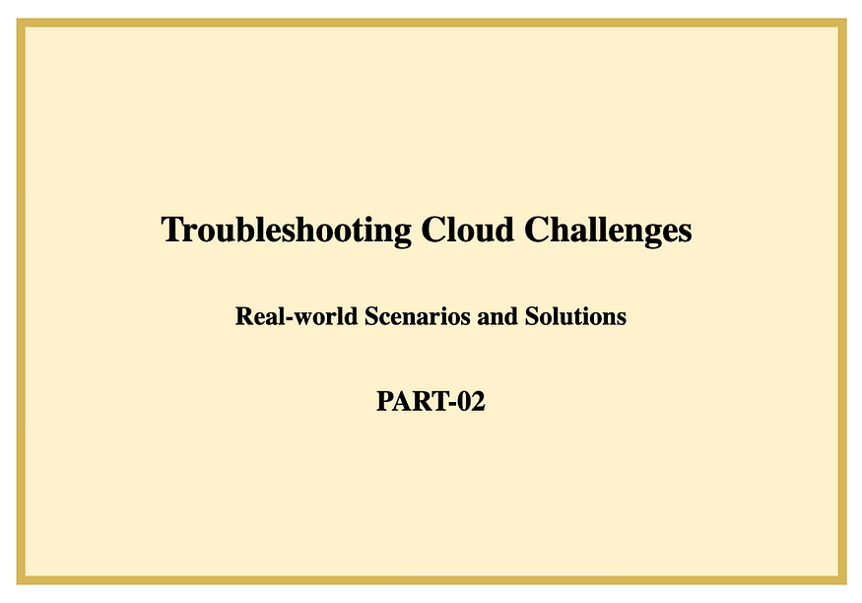

**Welcome to our blog series on “Troubleshooting Cloud Challenges: Real-world Scenarios and Solutions.”**

In this series, we address common cloud issues and provide practical solutions to empower you with the essential troubleshooting skills for a seamless cloud experience.

Let’s dive in and conquer cloud complexities together!

## Scenario 1: “Cloud Migration Performance Issues”

After migrating a workload to the cloud, you notice performance degradation compared to the on-premise environment.

**Possible Solutions:**

1. Review Cloud Resource Sizing: Check if the cloud resources (e.g., VM instances, database storage) are appropriately sized to handle the workload’s demands.
2. Monitor Network Latency: Monitor the network latency between the cloud and on-premise environments and identify any bottlenecks affecting performance.
3. Optimize Data Transfer: Optimize data transfer between on-premise and cloud resources to reduce latency and improve performance.

## Scenario 2: “Hybrid Cloud Identity and Access Management (IAM) Challenges”

Managing IAM permissions across hybrid cloud environments poses difficulties in ensuring consistent access control.

**Possible Solutions:**

1. Implement Single Sign-On (SSO): Consider implementing SSO solutions to centralize user authentication and simplify IAM management.
2. Use Federated IAM: Use federated IAM solutions to extend on-premise IAM capabilities to the cloud environment.
3. Leverage IAM Roles: Utilize IAM roles with trust relationships between on-premise and cloud environments for seamless access.

## Scenario 3: “Slow Application Response Time”

Your cloud-hosted application experiences slow response times, affecting user experience.

**Possible Solutions:**

1. Monitor Resource Utilization: Analyze CPU, memory, and network usage to identify resource bottlenecks.
2. Optimize Database Queries: Fine-tune database queries to improve application performance.
3. Implement Caching: Use caching mechanisms to store frequently accessed data and reduce database load.

## Scenario 4: “API Rate Limit Exceeded”

Your API-based service faces frequent rate limit exceeded errors due to high usage.

**Possible Solutions:**

1. Optimize API Usage: Minimize unnecessary API calls and ensure efficient use of API endpoints.
2. Request Rate Limit Increase: Contact the service provider to request a higher API rate limit.
3. Implement API Throttling: Apply API throttling to control and limit the number of requests per user.

## Scenario 5: “Intermittent Network Connectivity”

Instances in your cloud environment experience intermittent network connectivity issues.

**Possible Solutions:**

1. Review Security Group Rules: Check security group configurations to ensure correct inbound and outbound rules.
2. Monitor Network Traffic: Analyze network traffic patterns to identify potential disruptions.
3. Implement Network Monitoring: Set up continuous network monitoring to detect connectivity fluctuations.

## Scenario 6: “Containerized Application Scaling Challenges”

Your containerized application struggles to scale efficiently to meet demand.

**Possible Solutions:**

1. Optimize Docker Configuration: Review Docker settings and resource allocation for containers.
2. Implement Horizontal Scaling: Add more container instances to handle increased workload.
3. Monitor Container Metrics: Use container orchestration tools to monitor resource usage and scaling behavior.

## Scenario 7: “Cloud Billing Spike”

Unexpectedly high cloud service bills are observed, impacting your budget.

**Possible Solutions:**

1. Analyze Resource Usage: Identify resource-intensive services and optimize their usage.
2. Set Up Cost Alerts: Implement cost alerts to be notified of potential budget breaches.
3. Implement Resource Tagging: Use resource tagging for better cost allocation and monitoring.

## Scenario 8: “Data Loss in Cloud Storage”

Critical data stored in the cloud storage is accidentally deleted or lost.

**Possible Solutions:**

1. Implement Data Backup: Set up regular automated backups of your cloud storage.
2. Use Versioning: Enable versioning for objects in the cloud storage to recover previous versions.
3. Implement Data Replication: Maintain copies of data in different regions for redundancy.

## Scenario 9: “Microservices Communication Failures”

Microservices within your application fail to communicate effectively, leading to errors.

**Possible Solutions:**

1. Verify Service Discovery: Ensure proper service discovery mechanisms are in place.
2. Monitor Service Health: Set up health checks and monitoring for microservices.
3. Review Network Policies: Check network policies and firewalls for inter-service communication.

## Scenario 10: “Cloud Database Replication Lag”

Replicated databases in different regions experience significant replication lag.

**Possible Solutions:**

1. Optimize Network Configuration: Ensure high-speed and low-latency network connections between regions.
2. Adjust Replication Settings: Fine-tune replication parameters for faster data synchronization.
3. Monitor Replication Lag: Implement monitoring to detect and address replication delays promptly.

## Scenario 11: “Cloud-Native Function Cold Start Failures”

Your serverless functions consistently experience failures during cold starts.

**Possible Solutions:**

1. Optimize Function Size: Reduce function package size to shorten cold start times.
2. Warm-Up Functions: Implement scheduled warm-up requests to keep functions active.
3. Adjust Memory Allocation: Allocate appropriate memory resources to functions for optimal performance.

## Scenario 12: “Cloud Backup Integrity Check Failure”

Regular integrity checks on cloud backups are failing, raising data integrity concerns.

**Possible Solutions:**

1. Verify Backup Software Compatibility: Ensure backup software is compatible with cloud storage services.
2. Implement Regular Checks: Schedule regular integrity checks and monitor results closely.
3. Test Data Restoration: Periodically restore data from backups to verify integrity.

## Scenario 13: “Container Orchestration Configuration Drift”

Container orchestration platform configurations drift from the desired state.

**Possible Solutions:**

1. Implement Infrastructure as Code (IaC): Use IaC tools to manage and version control orchestration configurations.
2. Regular Configuration Audits: Perform routine audits to detect and correct configuration drift.
3. Automated Configuration Checks: Set up automated checks to ensure orchestration configurations match expectations.

## Scenario 14: “Cloud Service Unavailability During Scaling”

Your cloud service experiences brief unavailability during scaling operations.

**Possible Solutions:**

1. Implement Blue-Green Deployments: Use blue-green deployment strategies to minimize downtime.
2. Set Up Rolling Updates: Implement rolling updates to gradually deploy new versions without service interruption.
3. Monitor Scaling Activities: Monitor scaling events and take action to address any service disruptions.

## Scenario 15: “Cloud API Gateway Bottlenecks”

API Gateway experiences performance bottlenecks, leading to slow response times.

**Possible Solutions:**

1. Optimize API Gateway Settings: Review and optimize caching, throttling, and request/response settings.
2. Distribute API Traffic: Implement load balancing or regional distribution to evenly distribute requests.
3. Monitor API Gateway Metrics: Monitor API Gateway metrics to identify performance issues and trends.

## Scenario 16: “Container Image Vulnerabilities”

Vulnerabilities are discovered in your container images, posing security risks.

**Possible Solutions:**

1. Implement Image Scanning: Use container image scanning tools to identify vulnerabilities.
2. Regularly Update Images: Keep container images up to date with the latest patches and security fixes.
3. Implement Image Signing: Sign container images to ensure their authenticity and integrity.

## Scenario 17: “Cloud Service Auto Scaling Anomalies”

Auto scaling behavior for your cloud service is unpredictable and inconsistent.

**Possible Solutions:**

1. Review Auto Scaling Policies: Analyze and adjust auto scaling policies based on actual usage patterns.
2. Implement Predictive Scaling: Use predictive scaling algorithms to anticipate demand and adjust proactively.
3. Monitor Scaling Decisions: Regularly review and validate auto-scaling decisions to ensure accuracy.

## Scenario 18: “Database Performance Degradation After Schema Changes”

Performance degradation is observed in your database after making schema changes.

**Possible Solutions:**

1. Optimize Queries: Analyze and optimize database queries affected by the schema changes.
2. Perform Load Testing: Conduct load testing before and after schema changes to identify performance impacts.
3. Monitor Query Performance: Implement ongoing query performance monitoring to detect regressions.

## Scenario 19: “Cloud Data Center Geographical Failover Challenges”

Geographical failover between cloud data centers encounters synchronization issues.

**Possible Solutions:**

1. Implement Active-Active Architecture: Design an active-active setup to minimize synchronization challenges.
2. Use Consensus Algorithms: Implement consensus algorithms for data synchronization between data centers.
3. Monitor Replication Lag: Monitor replication lag closely and implement alerts for timely intervention.

## Scenario 20: “Cloud Resource Configuration Drift Detection”

Resource configurations in the cloud drift from their intended state.

**Possible Solutions:**

1. Implement Configuration Management: Utilize configuration management tools to enforce and monitor settings.
2. Regular Audits: Perform periodic audits to detect and rectify configuration drift.
3. Leverage Automation: Use automation to apply consistent configurations and prevent drift.

Acquiring troubleshooting skills in the cloud positively impacts an individual’s personal growth by fostering adaptability, problem-solving abilities, and self-confidence, leading to enhanced professional competence and career advancement.

**Thanks for exploring a few of the troubleshooting challenges and their solutions in Part 2 of our “Troubleshooting Cloud Challenges” blog series!**

Stay tuned for **Part 3**, where we’ll dive into more intriguing cloud scenarios.

Follow me on Medium for more engaging content on AWS, Azure, GCP, and beyond.

Let’s connect on [**LinkedIn**](https://www.linkedin.com/in/srija-anaparthy-86ba12184/) for the latest updates.

Your encouragement matters, so give this blog a clap if you found it helpful. Let’s keep learning and excelling in the world of cloud ☁️ together!

Happy learning and happy troubleshooting! Stay tuned for more! ❤❤❤

**Troubleshooting Cloud Challenges: Real-world Scenarios and Solutions- PART-03**

[Srija Anaparthy](https://medium.com/@srijaanaparthy?source=post_page-----1edf4c1b6b78--------------------------------)

Addressing common cloud issues and their solutions

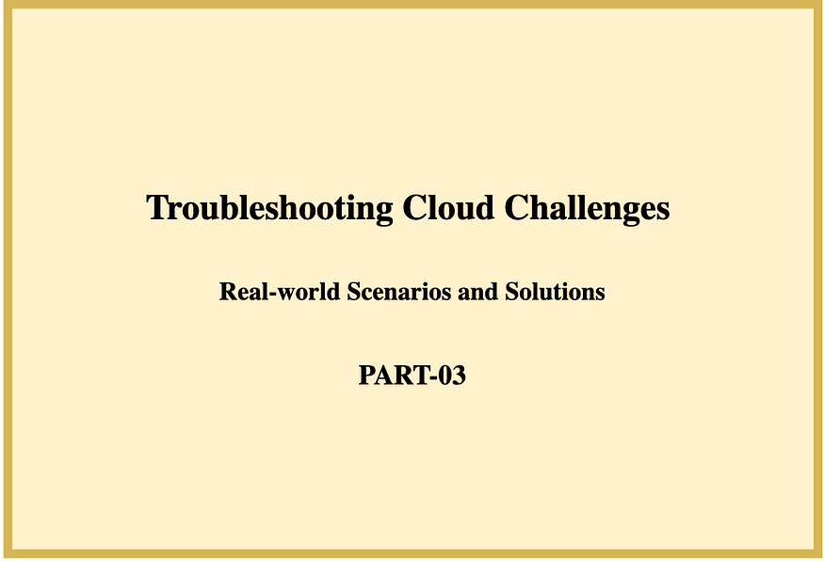

**Welcome to our blog series on “Troubleshooting Cloud Challenges: Real-world Scenarios and Solutions.”**

In this series, we address common cloud issues and provide practical solutions to empower you with the essential troubleshooting skills for a seamless cloud experience.

Let’s dive in and conquer cloud complexities together!

**Scenario 1: “Cloud-Native Monitoring and Alerting Failures”**

Your cloud-native monitoring and alerting system fails to provide timely notifications.

*Possible Solutions:*

1. *Review Alert Configuration:* Verify alert rules and ensure they are set up correctly.
2. *Implement Redundant Alerting:* Use multiple notification channels to ensure alerts are received.
3. *Regularly Test Alerts:* Conduct regular testing of alerting mechanisms to confirm their functionality.

**Scenario 2: “Cloud Load Balancer Configuration Errors”**

Load balancer misconfigurations lead to uneven distribution of traffic.

*Possible Solutions:*

1. *Review Load Balancer Settings:* Audit load balancer configuration and ensure proper settings.
2. *Implement Health Checks:* Set up health checks for backend instances to ensure proper load balancing.
3. *Monitor Traffic Distribution:* Regularly monitor traffic distribution to detect and address imbalances.

**Scenario 3: “Cloud Provider Regional Outage Impact”**

A regional outage in your cloud provider’s data centre affects your services.

*Possible Solutions:*

1. *Implement Multi-Region Redundancy:* Design services to run across multiple regions for high availability.
2. *Use Content Delivery Networks (CDNs):*Leverage CDNs to serve content from different regions during outages.
3. *Set Up Disaster Recovery (DR):* Implement a disaster recovery plan to failover services to unaffected regions.

**Scenario 4: “Ineffective Cloud Backup and Restore”**

Cloud backups fail to restore data accurately during recovery attempts.

*Possible Solutions:*

1. *Verify Backup Integrity:* Regularly test and verify backup data to ensure its integrity and recoverability.
2. *Implement Test Restores:* Perform routine test restores to validate backup and restore procedures.
3. *Review Backup Settings:* Double-check backup configuration settings to ensure proper retention and storage.

**Scenario 5: “Microservices API Versioning Challenges”**

Changes to microservices APIs lead to compatibility issues with existing clients.

*Possible Solutions:*

1. *Implement API Versioning:*Use proper versioning strategies such as URL versioning or header versioning.
2. *Deprecate Old APIs Gradually:* Provide a transition period for clients to migrate to the new API version.
3. *Monitor API Usage:*Monitor API usage to identify clients still using deprecated versions and notify them.

**Scenario 6: “Cloud DNS Misconfiguration”**

DNS misconfiguration causes service disruptions and incorrect routing.

*Possible Solutions:*

1. *Double-Check DNS Settings:* Review DNS settings for accuracy and ensure proper routing.
2. *Implement DNS Monitoring:* Set up DNS monitoring and alerts to detect misconfigurations promptly.
3. *Use DNS Traffic Management:* Implement DNS traffic management solutions to distribute traffic intelligently.

**Scenario 7: “Cloud Network Firewall Rule Conflicts”**

Conflicting firewall rules result in unexpected network access restrictions.

*Possible Solutions:*

1. *Review Firewall Rules:* Audit firewall rules to identify conflicts and remove redundant rules.
2. *Implement Network Segmentation:*Use network segmentation to isolate different parts of your infrastructure.
3. *Regularly Update Rules:*Maintain a schedule to review and update firewall rules as needed.

**Scenario 8: “Elevated Cloud Service Latency”**

Your cloud services experience increased latency, affecting user experience.

*Possible Solutions:*

1. *Monitor Resource Utilization:*Analyze resource usage patterns to identify performance bottlenecks.
2. *Optimize Content Delivery:*Implement content delivery networks (CDNs) for faster content distribution.
3. *Review Network Routes:*Check network routes and ensure they are optimized for low latency.

**Scenario 9: “API Gateway CORS Errors”**

Cross-Origin Resource Sharing (CORS) errors prevent web applications from accessing APIs.

*Possible Solutions:*

1. *Configure CORS Headers:* Ensure API Gateway is properly configured to include correct CORS headers.
2. *Implement Preflight Requests:* Set up preflight requests to handle CORS requests from browsers.
3. *Test Different Browsers:*Test API access from various browsers to catch potential CORS issues.

**Scenario 10: “Inaccurate Cloud Resource Tagging”**

Incorrect resource tagging leads to misallocation of costs and improper tracking.

*Possible Solutions:*

1. *Enforce Tagging Policies:* Implement policies to ensure proper tagging of all cloud resources.
2. *Regular Tag Audits:* Perform regular audits to verify accurate and consistent resource tagging.
3. *Automate Tagging:*Use automation to enforce standardized tagging during resource provisioning.

**Scenario 11: “Cloud API Authorization Flaws”**

Authorization vulnerabilities in your cloud APIs expose sensitive data.

*Possible Solutions:*

1. *Implement Role-Based Access Control (RBAC):* Apply RBAC to restrict access based on user roles and permissions.
2. *Regular Security Audits:* Conduct regular security audits to identify and address authorization flaws.
3. *Monitor API Usage:* Monitor API usage patterns to detect unauthorized access attempts.

**Scenario 12: “Cloud Backup Schedule Conflicts”**

Backup schedules overlap, causing resource contention and performance issues.

*Possible Solutions:*

1. *Optimize Backup Window:*Adjust backup schedules to stagger them and avoid overlapping.
2. *Implement Backup Quotas:* Set backup quotas to limit resource usage during backup processes.
3. *Monitor Backup Performance:* Monitor backup performance and adjust schedules based on performance metrics.

**Scenario 13: “Container Network Isolation Failures”**

Network isolation between containers fails, leading to unauthorized communication.

*Possible Solutions:*

1. *Review Container Network Settings:*Double-check container network configurations for isolation.
2. *Implement Network Policies:* Use network policies to control communication between containers.
3. *Regularly Audit Network Segmentation:* Conduct regular audits to ensure proper container network isolation.

**Scenario 14: “Cloud-Native Application Debugging Challenges”**

Debugging cloud-native applications proves difficult due to distributed components.

*Possible Solutions:*

1. *Implement Distributed Tracing:* Use distributed tracing tools to trace requests across microservices.
2. *Log Aggregation:* Centralize log collection and aggregation for easier debugging.
3. *Use Observability Tools:*Leverage observability platforms to monitor and troubleshoot application behavior.

**Scenario 15: “Cloud Resource Automation Failures”**

Automated resource provisioning and management scripts encounter errors.

*Possible Solutions:*

1. *Review Automation Scripts:*Inspect automation scripts for errors and misconfigurations.
2. *Implement Error Handling:*Enhance automation scripts with proper error handling and logging.
3. *Monitor Automation Execution:*Set up monitoring to track the execution of automated processes.

**Scenario 16: “Cloud Compliance Audit Failures”**

Failed compliance audits due to misconfigured security settings.

*Possible Solutions:*

1. *Implement Compliance Scanning:* Use compliance scanning tools to identify security gaps.
2. *Regular Compliance Audits:* Conduct frequent audits to ensure ongoing adherence to compliance standards.
3. *Review Security Group Rules:*Double-check security group rules to ensure compliance with policies.

**Scenario 17: “API Performance Bottlenecks”**

API endpoints experience performance bottlenecks during high load.

*Possible Solutions:*

1. *Optimize Database Queries:* Fine-tune database queries accessed by the API endpoints.
2. *Implement Caching:*Use caching mechanisms to store and serve frequently requested data.
3. *Scale API Instances:* Scale API instances horizontally to distribute the load effectively.

**Scenario 18: “Cloud Resource Deletion Accidents”**

Critical cloud resources are accidentally deleted, causing service disruption.

*Possible Solutions:*

1. *Enable Resource Locks:* Implement resource locks to prevent accidental deletion.
2. *Implement Resource Backup:*Regularly back up critical resources to enable recovery.
3. *Implement Role-Based Access Control (RBAC):* Restrict deletion permissions to authorized personnel.

**Scenario 19: “Container Runtime Failures”**

Container runtimes encounter errors and crashes, affecting application availability.

*Possible Solutions:*

1. *Update Container Runtime:* Keep container runtimes up to date with the latest stable versions.
2. *Monitor Container Health:*Implement monitoring for container runtime performance and health.
3. *Use Recovery Policies:*Configure container runtime recovery policies to handle failures.

**Scenario 20: “Cloud Service Provider API Changes”**

Changes in the cloud service provider’s API break integrations and functionality.

*Possible Solutions:*

1. *API Version Compatibility:*Stay informed about upcoming API changes and update integrations accordingly.
2. *Implement API Versioning:* Build applications to support multiple API versions during transition periods.
3. *Regularly Test Integrations:*Perform regular testing to ensure continued compatibility with API changes.

**Scenario 21: “Cloud Network Segment Isolation”**

Network segments in the cloud environment fail to isolate traffic properly.

*Possible Solutions:*

1. *Review Network Segment Configurations:*Check virtual network settings for proper segmentation.
2. *Implement Network Access Control Lists (ACLs):*Use ACLs to control traffic between network segments.
3. *Regularly Audit Network Policies:*Conduct routine audits to ensure network segment isolation.

**Scenario 22: “Cloud Provider Service Quota Exceeded”**

Exceeding cloud service quotas results in service limitations and disruptions.

*Possible Solutions:*

1. *Monitor Quota Usage:* Regularly monitor and analyze resource usage against quotas.
2. *Request Quota Increase:* Contact the cloud provider to request quota increases in advance.
3. *Implement Quota Alerts:*Set up alerts to be notified when resource usage approaches predefined quotas.

Acquiring troubleshooting skills in the cloud positively impacts an individual’s personal growth by fostering adaptability, problem-solving abilities, and self-confidence, leading to enhanced professional competence and career advancement.

**Thanks for exploring a few of the troubleshooting challenges and their solutions in Part 3 of our “Troubleshooting Cloud Challenges” blog series!**

Stay tuned for more, where we’ll dive into more intriguing cloud scenarios.

Follow me on Medium for more engaging content on AWS, Azure, GCP, and beyond.

Let’s connect on [***LinkedIn***](https://www.linkedin.com/in/srija-anaparthy-86ba12184/) for the latest updates.

Your encouragement matters, so give this blog a clap if you found it helpful. Let’s keep learning and excelling in the world of cloud ☁️ together!

Happy learning and happy troubleshooting! Stay tuned for more! ❤❤❤